COAL LAB 11
BAZIL – UDDIN -KHAN 24K-0559 BSCS3H

TASK#1).
Output:
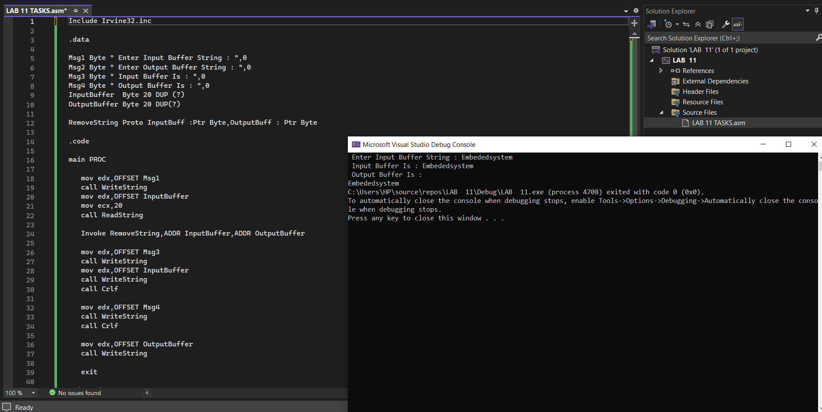
CODE:
Include Irvine32.inc

.data

Msg1 Byte " Enter Input Buffer String : ",0
Msg2 Byte " Enter Output Buffer String : ",0
Msg3 Byte " Input Buffer Is : ",0
Msg4 Byte " Output Buffer Is : ",0
InputBuffer Byte 20 DUP (?)
OutputBuffer Byte 20 DUP(?)

RemoveString Proto InputBuff :Ptr Byte,OutputBuff : Ptr Byte

.code

main PROC

mov edx,OFFSET Msg1
call WriteString
mov edx,OFFSET InputBuffer
mov ecx,20
call ReadString

Invoke RemoveString,ADDR InputBuffer,ADDR OutputBuffer

mov edx,OFFSET Msg3
call WriteString
mov edx,OFFSET InputBuffer
call WriteString
call Crlf

mov edx,OFFSET Msg4
call WriteString
call Crlf

mov edx,OFFSET OutputBuffer
call WriteString

exit

main Endp

RemoveString Proc InputBuff :Ptr Byte,OutputBuff : Ptr Byte

mov esi,InputBuff
mov edi,OutputBuff

cld

l1:
lodsb
cmp al,0

je Lexit

cmp al,'#'
je NextIteration
stosb

NextIteration:
jmp l1

Lexit:
mov al,0
stosb

ret

RemoveString Endp
End main

TASK#2).
Output:
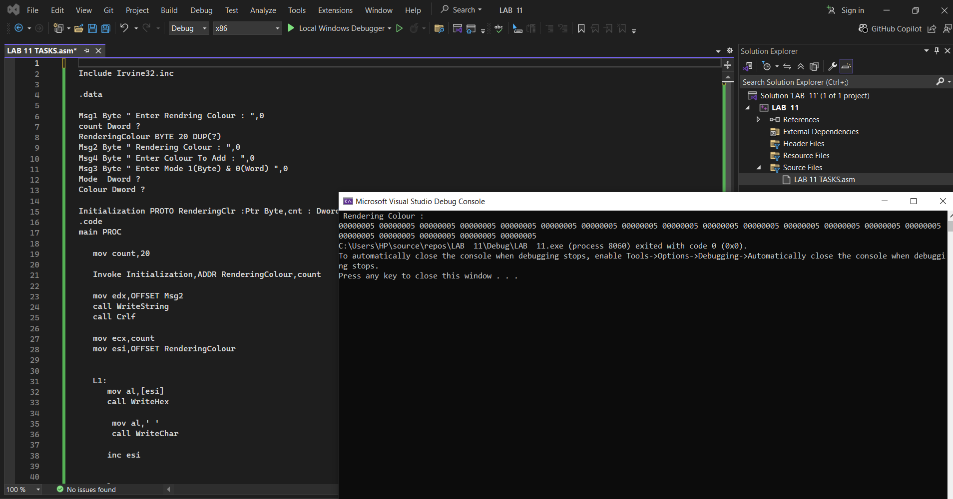

CODE:
Include Irvine32.inc

.data

Msg1 Byte " Enter Rendring Colour : ",0
count Dword ?
RenderingColour BYTE 20 DUP(?)
Msg2 Byte " Rendering Colour : ",0
Msg4 Byte " Enter Colour To Add : ",0
Msg3 Byte " Enter Mode 1(Byte) & 0(Word) ",0
Mode Dword ?
Colour Dword ?

Initialization PROTO RenderingClr :Ptr Byte,cnt : Dword
.code
main PROC

mov count,20

Invoke Initialization,ADDR RenderingColour,count

mov edx,OFFSET Msg2
call WriteString
call Crlf

mov ecx,count
mov esi,OFFSET RenderingColour

L1:
mov al,[esi]
call WriteHex

mov al,' '
call WriteChar

inc esi

loop L1
exit

main Endp

Initialization Proc RenderingClr :Ptr Byte,cnt : Dword

cld

mov edx,OFFSET Msg4
call WriteString
call ReadInt

mov Colour,eax

mov edi,RenderingClr

mov edx,OFFSET Msg3

call WriteString

call ReadInt

mov Mode,eax
cmp Mode,1
Je ByteRender

mov ax,word ptr Colour
mov ecx,cnt
shr ecx,1

rep stosw
jmp ExitFunc

ByteRender:
mov al,byte ptr Colour
mov ecx,Cnt
rep stosb

ExitFunc:
ret

Initialization Endp
End main

TASK#3).
Output:
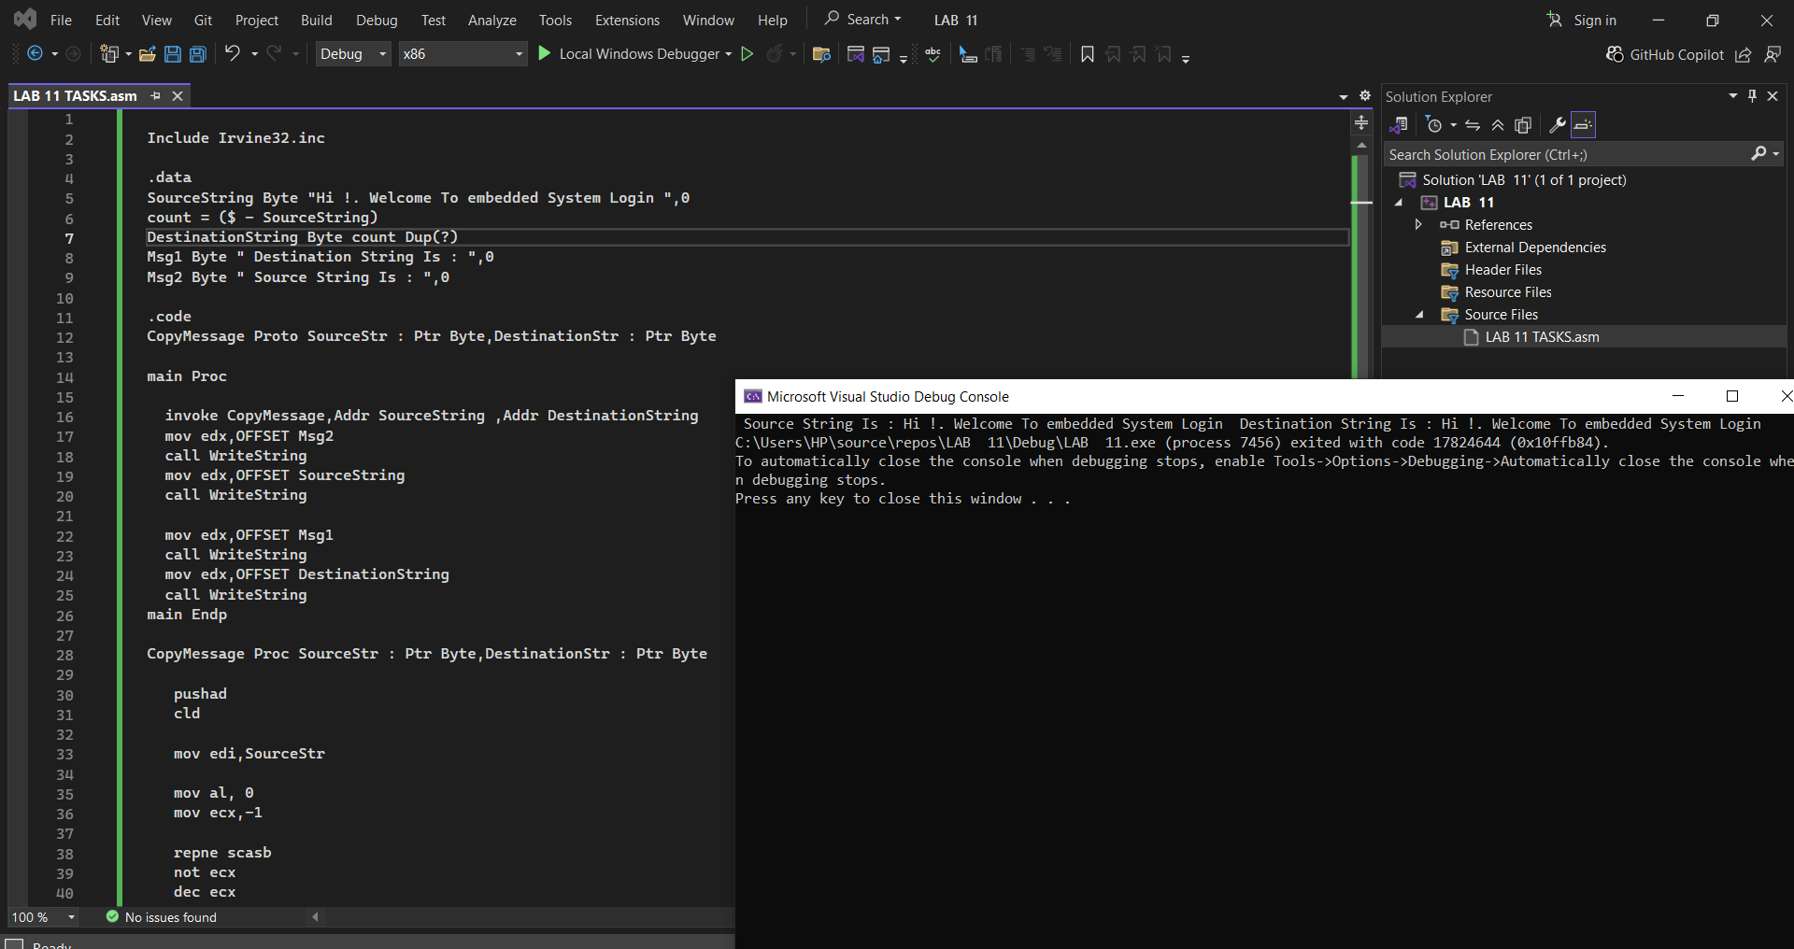

CODE:

Include Irvine32.inc

.data
SourceString Byte "Hi !. Welcome To embedded System Login ",0
count = ($ - SourceString)
DestinationString Byte count Dup(?)
Msg1 Byte " Destination String Is : ",0
Msg2 Byte " Source String Is : ",0

.code
CopyMessage Proto SourceStr : Ptr Byte,DestinationStr : Ptr Byte

main Proc

invoke CopyMessage,Addr SourceString ,Addr DestinationString
mov edx,OFFSET Msg2
call WriteString
mov edx,OFFSET SourceString
call WriteString

mov edx,OFFSET Msg1
call WriteString
mov edx,OFFSET DestinationString
call WriteString
main Endp

CopyMessage Proc SourceStr : Ptr Byte,DestinationStr : Ptr Byte

pushad
cld

mov edi,SourceStr

mov al, 0
mov ecx,-1

repne scasb
not ecx
dec ecx

mov esi,SourceStr
mov edi,DestinationStr

Rep movsb

popad
ret 8

CopyMessage Endp
End main

TASK#4).
OUTPUT:
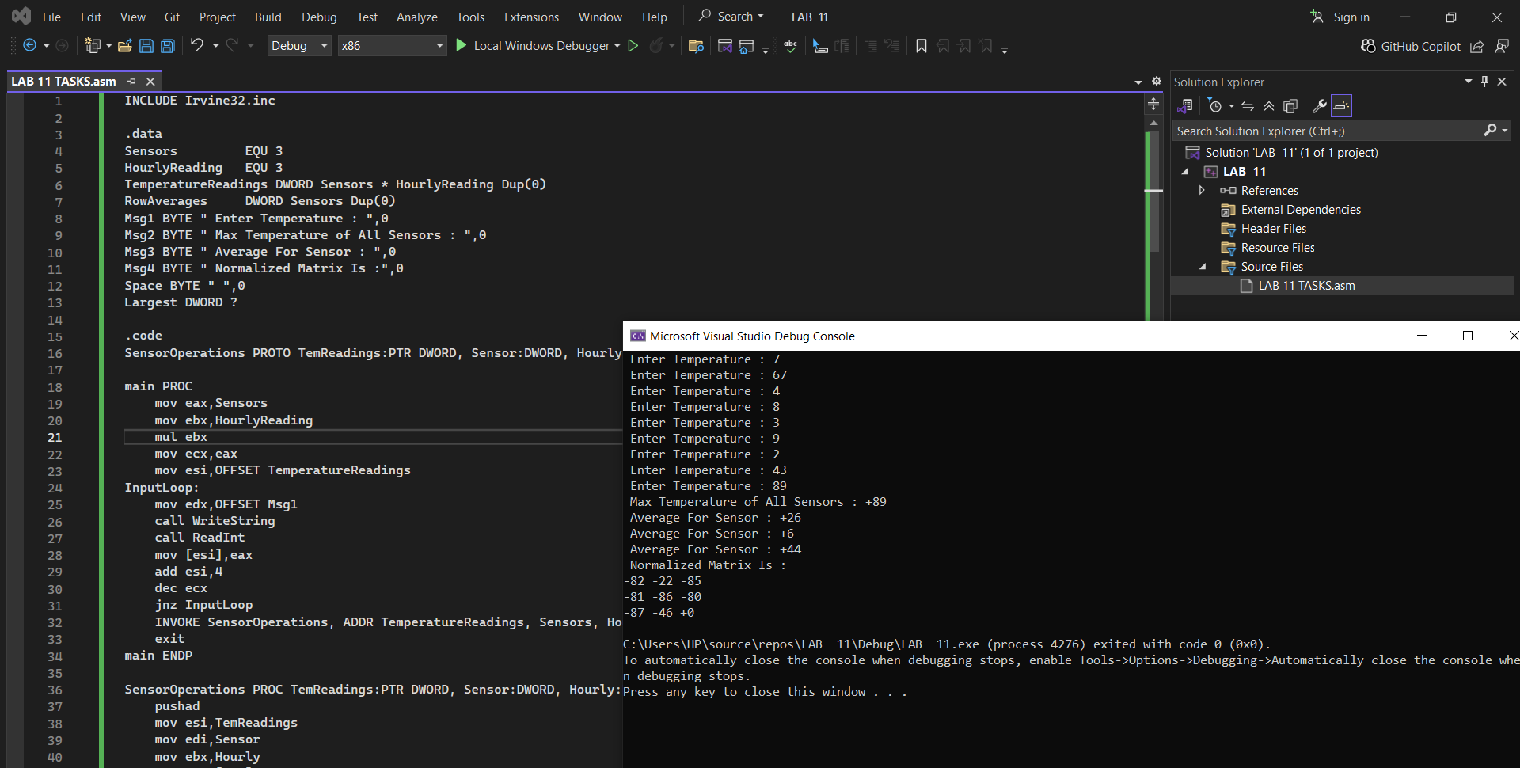

CODE:
INCLUDE Irvine32.inc

.data
Sensors EQU 3
HourlyReading EQU 3
TemperatureReadings DWORD Sensors * HourlyReading Dup(0)
RowAverages DWORD Sensors Dup(0)
Msg1 BYTE " Enter Temperature : ",0
Msg2 BYTE " Max Temperature of All Sensors : ",0
Msg3 BYTE " Average For Sensor : ",0
Msg4 BYTE " Normalized Matrix Is :",0
Space BYTE " ",0
Largest DWORD ?

.code
SensorOperations PROTO TemReadings:PTR DWORD, Sensor:DWORD, Hourly:DWORD

main PROC
mov eax,Sensors
mov ebx,HourlyReading
mul ebx
mov ecx,eax
mov esi,OFFSET TemperatureReadings
InputLoop:
mov edx,OFFSET Msg1
call WriteString
call ReadInt
mov [esi],eax
add esi,4
dec ecx
jnz InputLoop
INVOKE SensorOperations, ADDR TemperatureReadings, Sensors, HourlyReading
exit
main ENDP

SensorOperations PROC TemReadings:PTR DWORD, Sensor:DWORD, Hourly:DWORD
pushad
mov esi,TemReadings
mov edi,Sensor
mov ebx,Hourly
mov eax,[esi]
mov Largest,eax

mov ecx,0

FindMaxRow:
mov edx,0

FindMaxCol:
mov eax,ecx
imul eax,ebx
add eax,edx
shl eax,2
mov eax,[esi+eax]
cmp eax,Largest
jle FM_N
mov Largest,eax

FM_N:
inc edx
cmp edx,ebx
jl FindMaxCol

inc ecx
cmp ecx,edi
jl FindMaxRow

mov edx,OFFSET Msg2
call WriteString
mov eax,Largest
call WriteInt
call Crlf

mov ecx,0

AvgRowLoop:

mov edx,0
mov ebp,0

AvgColLoop:

mov eax,ecx
imul eax,ebx
add eax,edx
shl eax,2
mov eax,[esi+eax]
add ebp,eax
inc edx

cmp edx,ebx

jl AvgColLoop
mov eax,ebp
cdq
idiv ebx

mov [RowAverages + ecx*4],eax
inc ecx
cmp ecx,edi
jl AvgRowLoop

mov ecx,0

PrintAvgLoop:
mov edx,OFFSET Msg3
call WriteString
mov eax,[RowAverages + ecx*4]
call WriteInt
call Crlf
inc ecx
cmp ecx,edi
jl PrintAvgLoop

mov edx,OFFSET Msg4
call WriteString
call Crlf

mov ecx,0

NRow:
mov edx,0

NCol:
mov eax,ecx
imul eax,ebx
add eax,edx
shl eax,2
mov ebp,[esi+eax]
sub ebp,Largest
mov [esi+eax],ebp
inc edx
cmp edx,ebx
jl NCol
inc ecx
cmp ecx,edi
jl NRow

mov ecx,0

PrintRow:
mov edx,0

PrintCol:
mov eax,ecx
imul eax,ebx
add eax,edx
shl eax,2
mov eax,[esi+eax]
call WriteInt
push edx
mov edx,OFFSET Space
call WriteString
pop edx
inc edx
cmp edx,ebx
jl PrintCol
call Crlf
inc ecx
cmp ecx,edi
jl PrintRow

popad

ret
SensorOperations ENDP
END main

TASK#5).
OUTPUT:
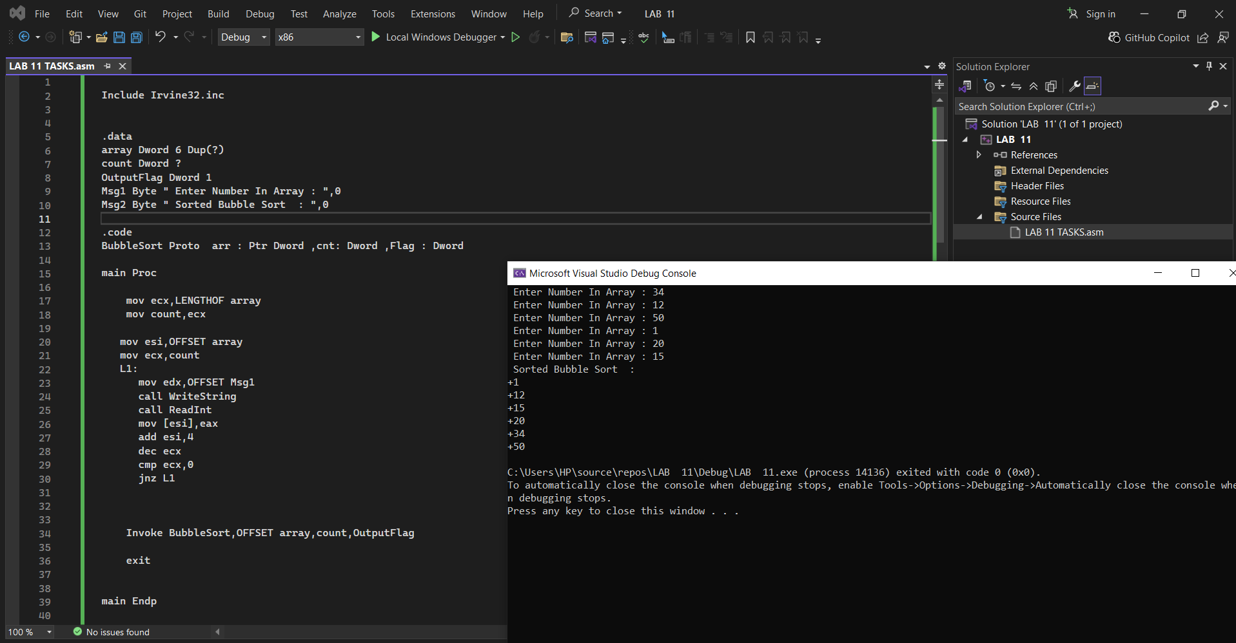
CODE:

Include Irvine32.inc

.data
array Dword 6 Dup(?)
count Dword ?
OutputFlag Dword 1
Msg1 Byte " Enter Number In Array : ",0
Msg2 Byte " Sorted Bubble Sort : ",0

.code
BubbleSort Proto arr : Ptr Dword ,cnt: Dword ,Flag : Dword

main Proc

mov ecx,LENGTHOF array
mov count,ecx

mov esi,OFFSET array
mov ecx,count
L1:
mov edx,OFFSET Msg1
call WriteString
call ReadInt
mov [esi],eax
add esi,4
dec ecx
cmp ecx,0
jnz L1

Invoke BubbleSort,OFFSET array,count,OutputFlag

exit

main Endp

BubbleSort Proc arr : Ptr Dword , cnt : Dword ,Flag : Dword

Local SwapFlag : Dword
pushad
mov SwapFlag,1

OuterLoop:
mov SwapFlag,0
mov ecx,cnt
dec ecx
mov esi,arr

InnerLoop:
mov eax,[esi]
mov ebx,[esi +4]
cmp eax,ebx
jle NextIteration
mov [esi],ebx
mov [esi + 4],eax
mov SwapFlag,1

NextIteration:
dec ecx
add esi,4
cmp ecx,0
jnz InnerLoop

cmp SwapFlag ,1
je OuterLoop

Done:
cmp Flag,1
jz PrintLoop
jmp ExitPro

PrintLoop:

mov esi,arr
mov ecx,cnt
mov edx,OFFSET Msg2
call WriteString
call Crlf

L2:

mov eax,[esi]
call WriteInt
call Crlf
add esi,4
dec ecx
cmp ecx,0
jnz L2

ExitPro:
popad
ret 12

BubbleSort Endp

End main

